3. Web API Hands on
1. Objectives
- Demonstrate creation of an action method that returns a list of custom class entity objects.
- Create an Employee model class and use the AllowAnonymous attribute and HttpGet action method.
- Understand the use of the FromBody attribute to read a model object from the request body.
- Demonstrate a custom action filter using ActionFilterAttribute and OnActionExecuting method to intercept requests.
- Create a custom exception filter to handle application exceptions, log exception details to a file, and return an Internal Server Error response.

Procedure and Implementation

Installing Required NuGet Package
The required Web API compatibility package was installed using the following command:
dotnet add package Microsoft.AspNetCore.Mvc.WebApiCompatShim
The package was successfully added to the project.

Web API Using Custom Model Class
A custom Employee model class was created with the following properties:
- Id
- Name
- Salary
- Permanent
- Department
- Skills
- DateOfBirth
Employee Model:
public class Employee
{
public int Id { get; set; }
public string Name { get; set; }
public int Salary { get; set; }
public bool Permanent { get; set; }
public Department Department { get; set; }
public List<Skill> Skills { get; set; }
public DateTime DateOfBirth { get; set; }
}
Supporting classes were created:
Department Class
public class Department
{
public int Id { get; set; }
public string Name { get; set; }
}
Skill Class
public class Skill
{
public int Id { get; set; }
public string Name { get; set; }
}

Employee Controller Creation
A new controller named:
EmployeeController.cs
was created.
The controller contains:
- HTTP GET action method
- HTTP POST action method
- HTTP PUT action method

Creating Employee Records
A private method was created:
private List<Employee> GetStandardEmployeeList()
This method returns a list of Employee objects containing sample employee data.
Example:
Id | Name | Salary | Permanent
1 | Aishu | 50000 | True
2 | John | 40000 | False

HTTP GET Action Method
The GET action method was created to return a list of Employee objects.
[HttpGet]
[ProducesResponseType(StatusCodes.Status200OK)]
public ActionResult<List<Employee>> GetStandard()
{
return GetStandardEmployeeList();
}
The method successfully returns employee details.

AllowAnonymous Attribute
The AllowAnonymous attribute allows the action method to be accessed without authorization.
Example:
[AllowAnonymous]
[HttpGet]
public ActionResult<List<Employee>> GetStandard()
{
return GetStandardEmployeeList();
}

FromBody Attribute Usage
The FromBody attribute is used to read the Employee object from the HTTP request body instead of query string parameters.
POST method:
[HttpPost]
public ActionResult<Employee> Post([FromBody] Employee employee)
{
return employee;
}
PUT method:
[HttpPut]
public ActionResult<Employee> Put([FromBody] Employee employee)
{
return employee;
}

Swagger Testing
The API was tested using Swagger UI.
Swagger URL:
http://localhost:5263/swagger
GET API:
GET /Employee
Response:
[
{
"id":1,
"name":"Aishu",
"salary":50000,
"permanent":true
},
{
"id":2,
"name":"John",
"salary":40000,
"permanent":false
}
]
The response status was:
200 OK
Verification Results
Test | Expected Result | Observed Result
Employee GET in Swagger | Employee list with 200 OK | Successfully returned Employee list
Authorization header missing | 400 - Invalid request - No Auth token | Pending
Exception in GET action | 500 Internal Server Error | Pending
Exception logging | Exception details written to ErrorLog.txt | Pending

Screenshots
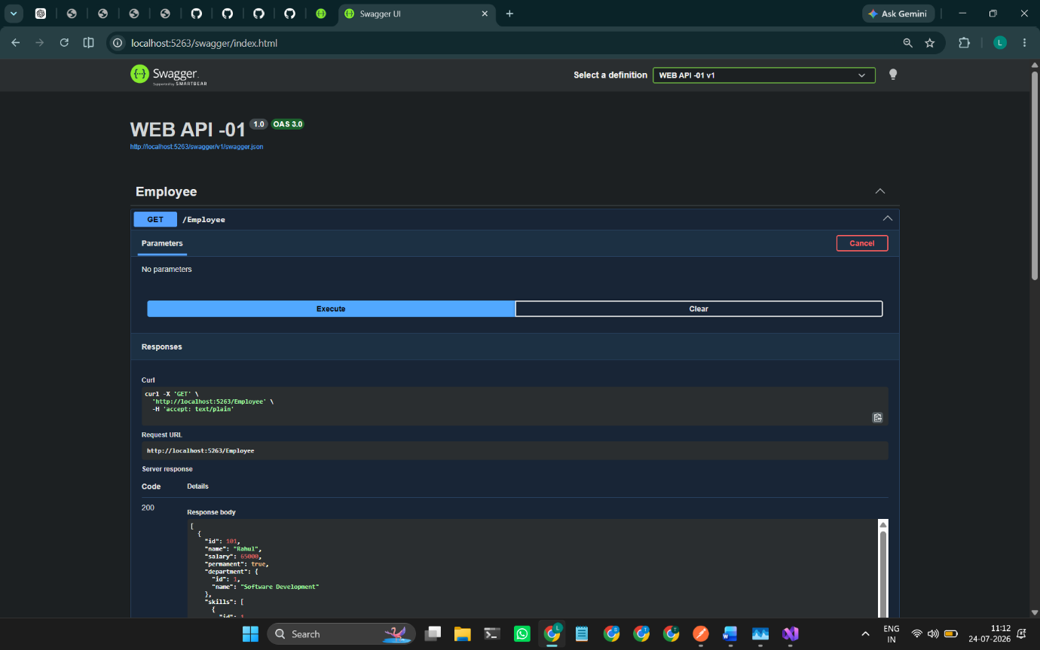
1: Swagger GET response showing the custom Employee list and 200 OK response
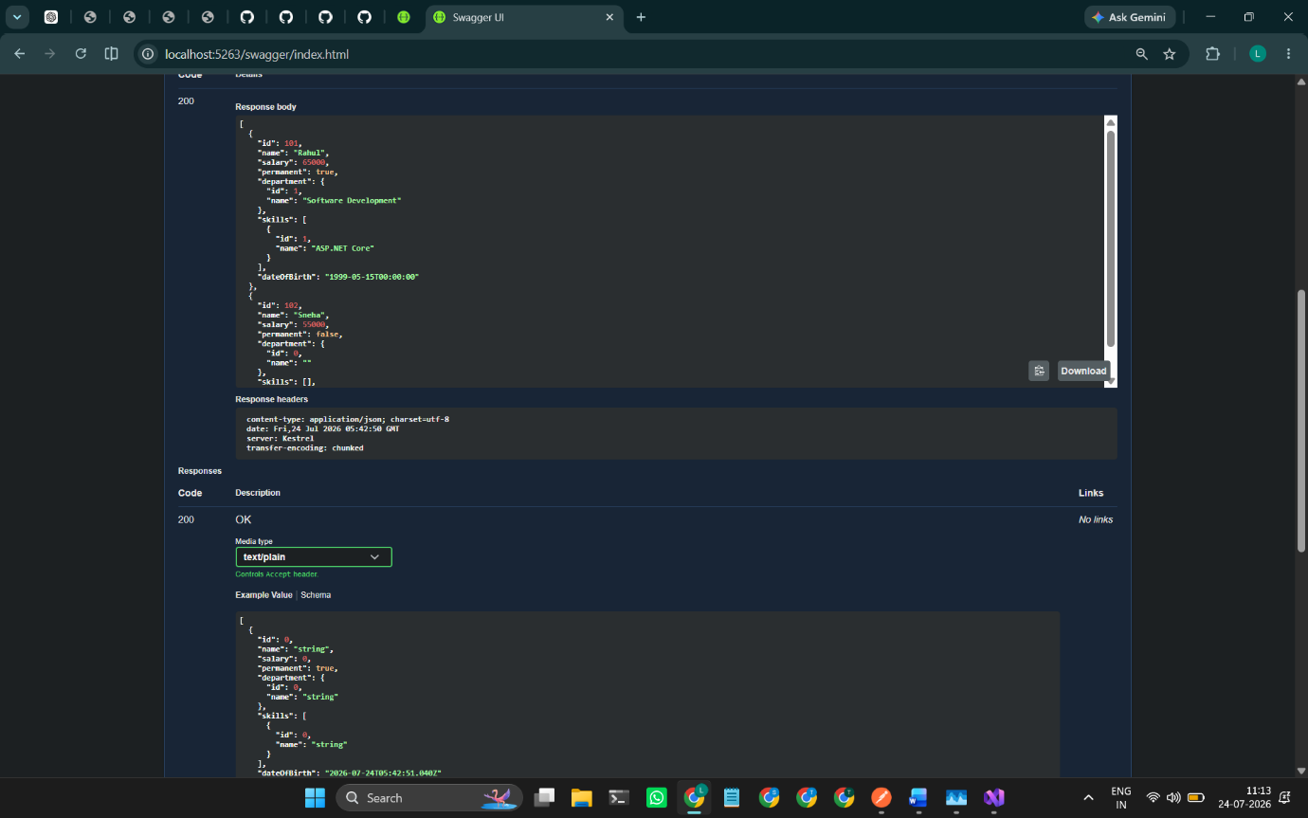

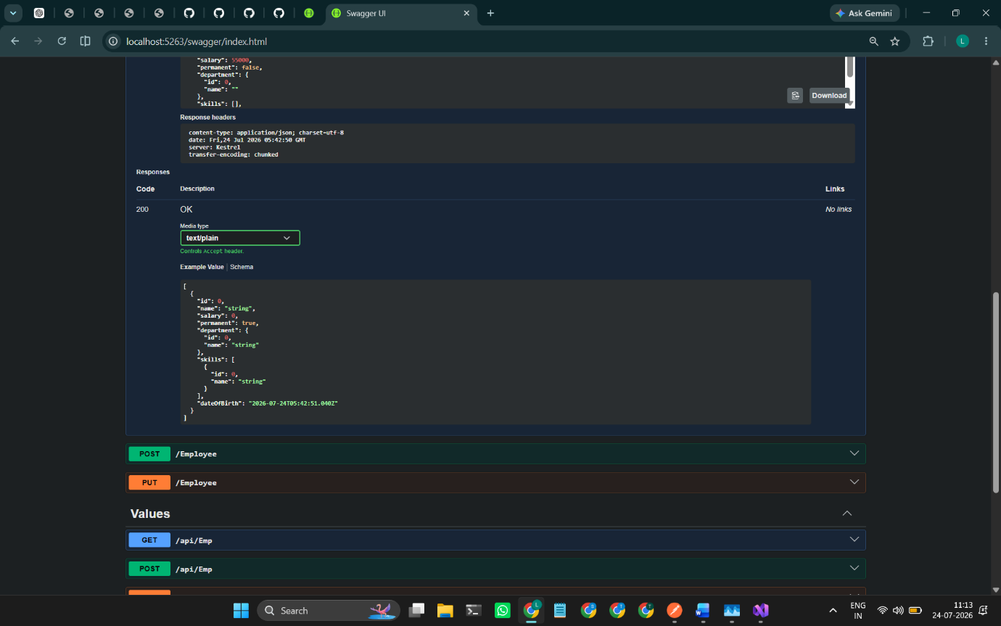
Figure 2: Custom Authorization Filter response showing 'Invalid request - No Auth token'.
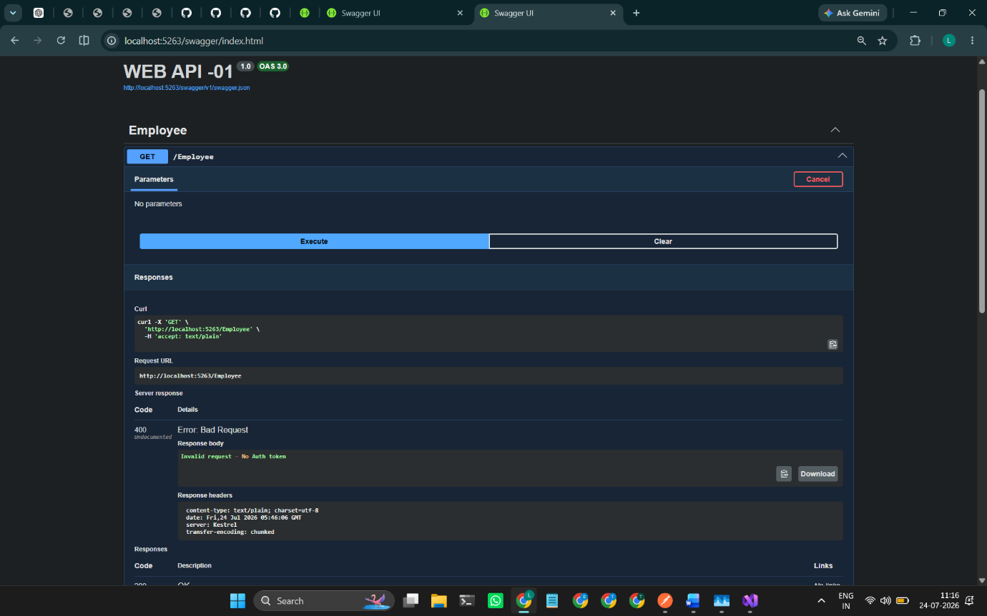

Figure 3: Swagger GET response showing 500 Internal Server Error and 'An internal server error occurred.'.

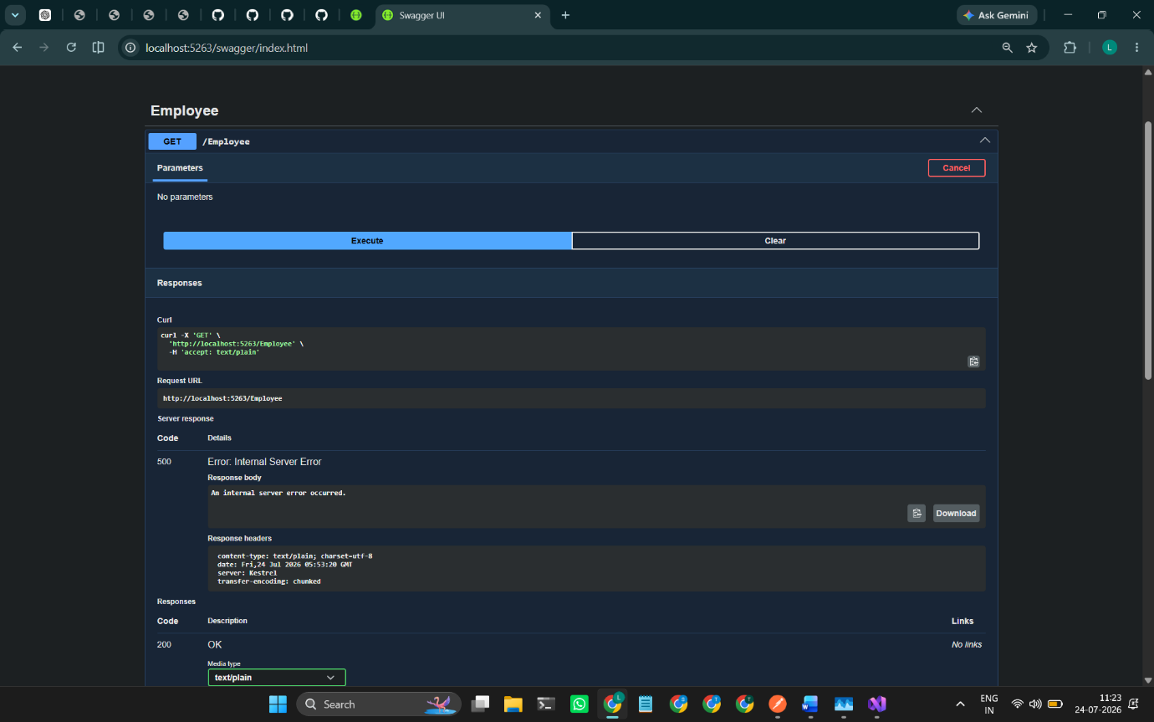
Figure 4: ErrorLog.txt containing the logged exception details.
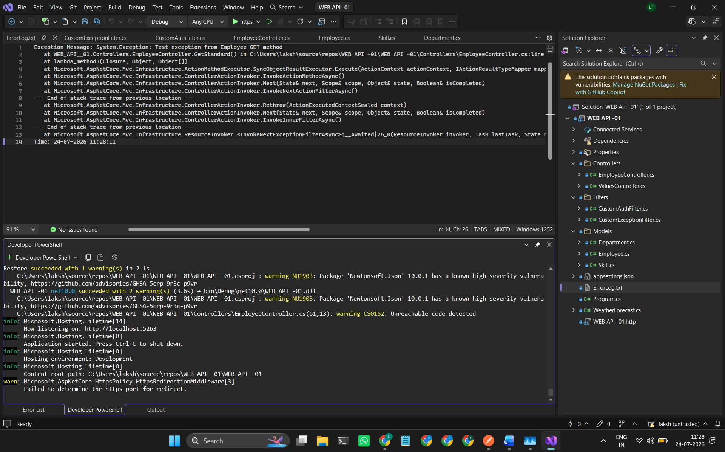
Result
Successfully created an ASP.NET Core Web API application using a custom Employee model class and implemented action methods to return Employee entity objects.
The HTTP GET action method was created to retrieve a list of Employee objects and was successfully tested using Swagger UI with a 200 OK response.
The FromBody attribute was implemented to read Employee objects from the request body for POST and PUT operations.
A custom Authorization Action Filter was created using ActionFilterAttribute and OnActionExecuting method to validate the Authorization header and Bearer token. The filter successfully intercepted invalid requests and returned appropriate error messages.
A custom Exception Filter was implemented using IExceptionFilter to handle application exceptions, capture exception details, write logs to ErrorLog.txt, and return a 500 Internal Server Error response.
All functionalities were successfully implemented and verified using Swagger UI.

